Computer Graphics

Lab –

Bezier curve drawing algorithm

Supervised By: Submitted By:

Dr Ajay Mittal Aniket Singh

UIET CSE 3nd Year(Section-1)

Panjab University UE183010

Objective:

To draw a curve using Bezier curve drawing algorithm.

### Procedure:

**FOR BEZIER CURVE DRAWING ALGORITHM:**

curve

{

double step_size = 0.005, multi, t = 0.0;

double step = (1/step_size);

coeff_calc();

for(int j = 0; j<=step; j++){

vector<double> v1;

t = ((double)j*step_size);

double sum_x = 0.0, sum_y = 0.0;

for(int i = 0;i<=coun-1;i++){

multi = ((ber_coeff[i]*power(t, i))*(power(1.0f-t, (coun-1-i))));

sum_x += multi*point_x[i];

sum_y += multi*point_y[i];

}

v1.push_back(sum_x);

v1.push_back(sum_y);

v.push_back(v1);

}

}

**FOR COEFFICIENT CALCULATION:**

coeff_calc(){

for(int i = 0; i<coun; i++){

ber_coeff[i] = (fact(coun-1)/(fact(i)*fact(coun-1-i))); } }

Program Design

**FOR MOUSE INPUTS:**

mouse(int button, int state, int mousex, int mousey){

but_x = mousex ;

but_y = (screen_breadth) - mousey;

point_x[coun] = but_x;

point_y[coun] = but_y;

if(button == GLUT_LEFT_BUTTON && state == GLUT_DOWN){

check = true;

touch++;

plot_point(but_x, but_y, colour, 3);

}

else if(button==GLUT_RIGHT_BUTTON && state==GLUT_DOWN)

{

check = false;

touch = 0;

}

glutPostRedisplay();

}

**FOR RENDER FUNCTION:**

void render(void){

if((but_x != temp_x && but_y != temp_y) || (but_x == temp_x && but_y != temp_y) || (but_x != temp_x && but_y == temp_y)){

coun++;

if(check == false && touch == 0){

double a, b;

glClear(GL_COLOR_BUFFER_BIT);

for(int i = 0;i<coun; i++){

plot_point(point_x[i], point_y[i], colour_after, 9);

}

rough_line();

curve();

glColor3f(0.2, 0.7, 0.4);

for (int i = 0; i < v.size(); i++) {

if(i==0){

a = v[i][0];

b = v[i][1];

}

else{

glLineWidth(2);

glBegin(GL_LINES);

glVertex2f(a, b);

glVertex2f(v[i][0], v[i][1]);

glEnd();

a = v[i][0];

b = v[i][1];

}

}

glFlush();

}

temp_x = but_x;

temp_y = but_y;

}

}

**FOR INIT FUNCTION:**

init(float r, float g, float b){

glViewport(0, 0, screen_breadth, screen_height);

glClear(GL_COLOR_BUFFER_BIT);

glClearColor(r, g, b, 1.0);

glMatrixMode(GL_PROJECTION);

glLoadIdentity();

gluOrtho2D(0.0,(GLdouble)screen_height,0.0,(GLdouble)screen_breadth);

}

**FOR MAIN FUNCTION:**

main(int argc, char** argv)

{

glutInit(&argc,argv);

glutInitDisplayMode(GLUT_SINGLE | GLUT_RGB);

glutInitWindowPosition(100, 100);

glutInitWindowSize(screen_height, screen_breadth);

glutCreateWindow("Bezier Curve");

init(0.0, 0.0, 0.0);

glutDisplayFunc(render);

glutMouseFunc(mouse);

glutMainLoop();

}

The Program consists of a function and main function. The function named as curve is used finding the coordinates which will be used for Curve drawing, given the points.

**MOUSE FUNCTION:** Inputs is taken through mouse click (left click) and to take the last point input, right click was used.

**RENDER FUNCTION:** In render function, which runs after inputs are taken. It draws the curve after the last point was taken through right click.

**INIT FUNCTION:** Init is used to initialize the background in black colour and to reset some buffers

**MAIN FUNCTION:** Main function is used to set display window’s size and position.

**COEFFICIENT CALCULATION FUNCTION:** Coefficients are calculated and stored in a global array.

**BEZIER CURVE FUNCTION:** Given the Points, all the points are calculated in the curve by this formula.



These values are stored in a vector which are later plotted in render.

## Output:

All the input points are displayed by square box. Pink line is the line after joining them and green line is Bezier curve.

Stepsize = 0.05

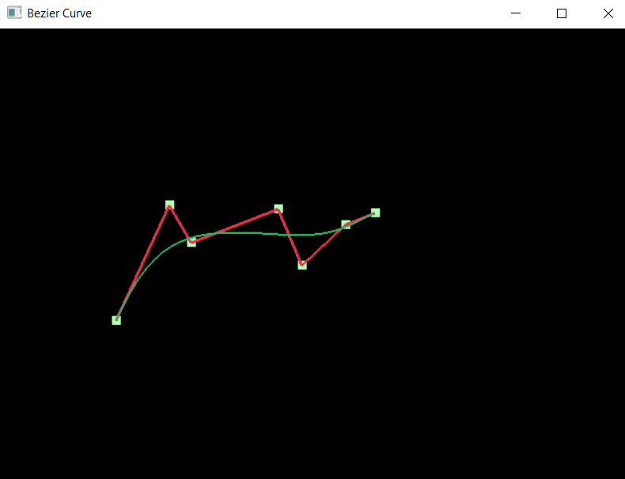

## Analysis of the Program

The program is written to draw a curve using Bezier algorithm. In this we are finding Bezier coefficient which are

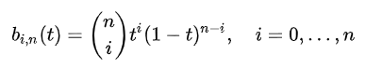

These are multiplied with the x and y coordinated which various t values ranging from 0 to 1. According to the step-size and number of points plotted we get different number of coefficients. Generally degree of the polynomial is number of point plotted minus one.

Result:

As shown in the outputs, we can draw any curve using Bezier curve drawing algorithm with, in the 2-D plane.